Illinois Pumpkin Field Day - 2005

PLACE: Southern Illinois University Belleville Research Center in Belleville, IL

DATE: September 8, 2005
TIME: 10:00 A.M. – 2:30 P.M.
Registration is free and lunch will be provided.

Commercial pumpkin growers and others interested in pumpkin production are encouraged to come to Belleville, IL on September 8 to participate in the 2005 Illinois Pumpkin Field Day. This event provides attendees with an opportunity to listen to researchers and extension specialists discuss issues in pumpkin production as well as to showcase on-going pumpkin field research. This event for 2005 is being hosted by the Southern Illinois University Belleville Research Center. Speakers from the University of Illinois, UI Extension and Southern Illinois University will be on hand.

Tentative Presentations:
Disease Management in Pumpkin Production – M. Babadoost
Pumpkin Insect Update – Rick Weinzierl
Pumpkin Varieties – Alan Walters
Economics of Pumpkin Production – Alan Walters
Sandea Herbicide Management in Pumpkins – Elizabeth Wahle
Potential New Pre-Emergence Herbicides for Pumpkins – Elizabeth Wahle
Cover Crop Integration in Pumpkin Production Systems – Maurice Ogutu
Hive and the Honey Bee – Mark Hoard, Stu Jacobson

Attendees should arrive for on-site registration by 10:00 am. Research Tours will begin by 10:30 and lunch will be from 12:00-12:45. Afternoon tours will resume after lunch and continue until approximately 2:30 pm. Participants coming west on I-64 can find the Southern Illinois Belleville Research Center by taking exit 23 and going south on IL Rt. 4 until the intersection with IL Rt. 161 is reached (about 1.5 miles), then take a right and it is about 2 miles west of IL Rt. 4 on IL Rt. 161 on the left side of the road. Participants coming east from the St. Louis area can take exit 19 off of I-64 and go south until the intersection with IL Rt. 161 is reached, then take a left and follow IL Rt. 161 east for approximately 3 miles and the Southern Illinois Belleville Research Center will be on the right. Questions may be directed to Alan Walters (618-453-3446, awalters@siu.edu) or Elizabeth Wahle (618-692-9434, wahle@uiuc.edu).

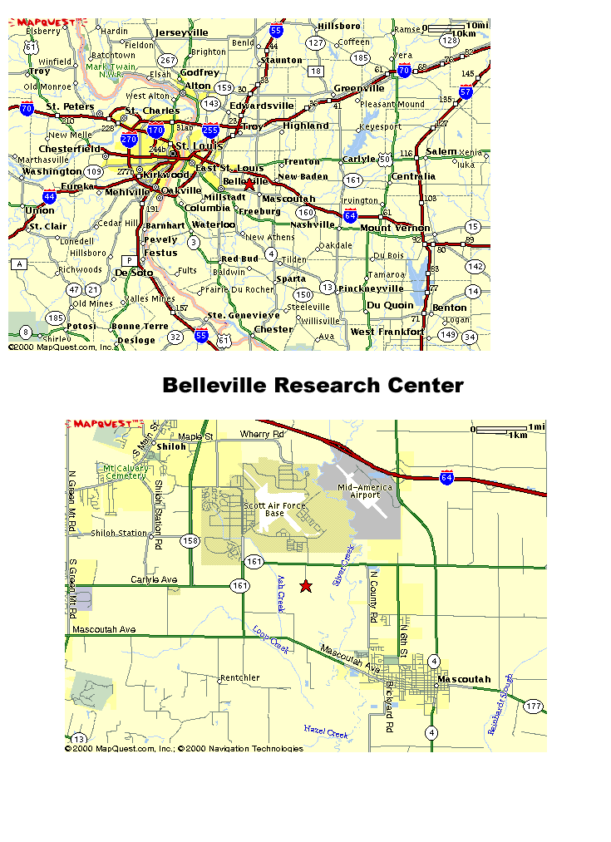

2036 Charles Ln, SIUC Belleville Research Center, Belleville, IL 62221-8615

